Department of Accountancy
and
Department of Banking and Finance
(in association with Finplan Edu.- ACCA.)
organises

Finance Symposium
(Building Financial Resilience)

Date: December 4, 2023
Venue: Law Building – 7th Floor (Conference Room)

Department of Accountancy and Department of Banking and Finance had a Finance Symposium in association with Finplan Edu.- ACCA. with the objective of guiding the students on the topic of Technology & The Future of Finance. The registrations were made online & a total of 119 students from FYBCOM, FYBFM & FYBAF had attended the session.
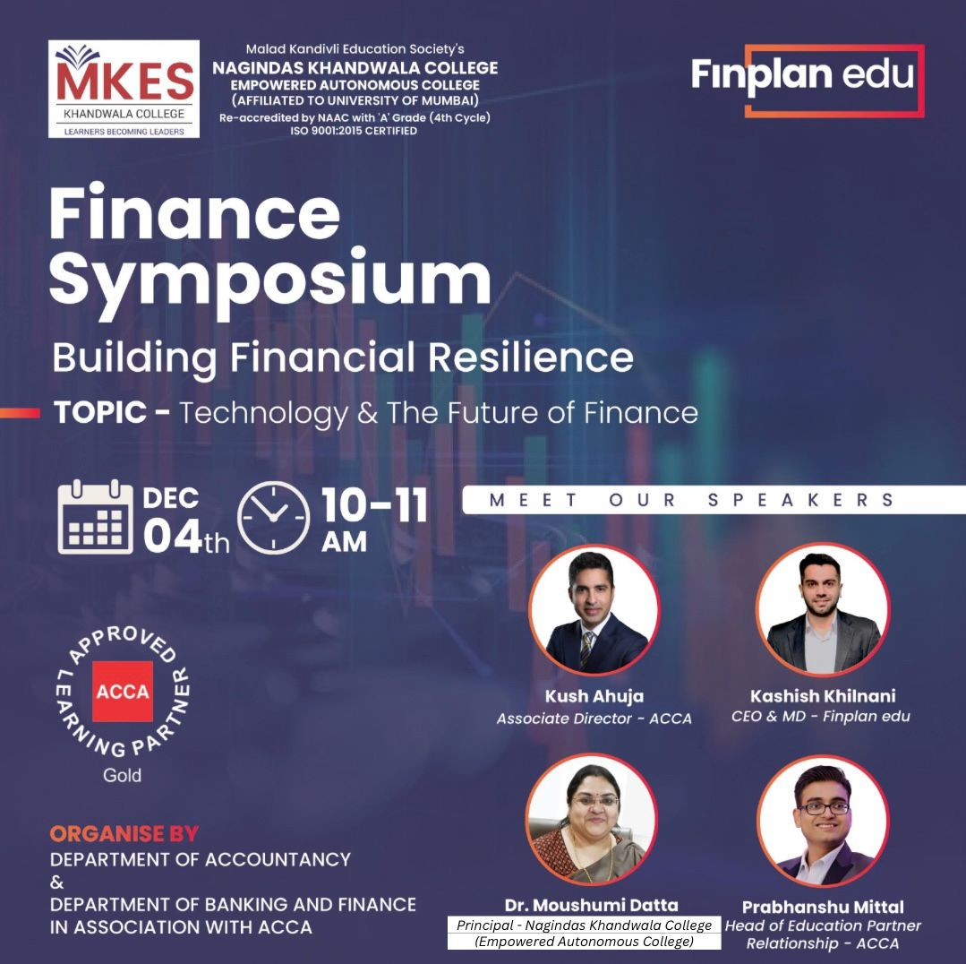
Geotagged Photos
